QUIZ – PROJECT REPORT

By,

Dhanush Jayadevan.

[Dhanushjayadevan274@gmail.com](mailto:Dhanushjayadevan274@gmail.com)

Table of Contents

1. Abstract.
2. Introduction.
3. Objectives.
4. Project Overview.
5. System Requirements.
6. Project Design and Architecture.
7. Implementation.
8. Usage and Instruction.
9. Testing and Validation.
10. Results and Discussion.
11. Conclusion.

1. Abstract

The Quiz Project is a command-line application designed to generate quizzes on various topics, particularly focusing on Java programming concepts. It allows users to create quizzes, add questions with multiple-choice options, specify correct answers, and take the quizzes to test their knowledge. The application provides a structured way to manage quiz questions, evaluate user responses, and give feedback based on the user’s performance.

2. Introduction

Background and Motivation

In an era where online learning and self-assessment tools are becoming increasingly important, the need for effective quiz applications is critical. This project aims to provide a simple, yet powerful tool for educators and learners to create and take quizzes on Java Programming.

3. Objectives

* Develop a command-line quiz application.
* Allow users to create and customize quizzes.
* Implement functionality for adding multiple-choice questions.
* Enables uses to take quizzes and receive feedback.
* Evaluate and display quiz results.

4. Project Overview

Description

The Quiz Project is a Java application that facilitates the creation and taking of quizzes. Users can add questions to a quiz, each with multiple-choice options, and specify the correct answer. Once the quiz is taken, the user's responses are evaluated, and a score is provided along with feedback.

Key Features

* Creation of quizzes with a custom name.
* Addition of multiple-choice questions.
* Evaluation of user responses.
* Display of scores and feedback.

Target Audience

* Java learners seeking to test their knowledge.
* Educators looking for a simple tool to create quizzes.
* Anyone interested in a quick self-assessment on Java programming concepts.

5. System Requirements

Hardware Requirements

* Processor: Intel i3 or equivalent.
* RAM: 4 GB or more.
* Storage: 100 MB of free disk space.

Software Requirements

* Operating System: Windows, macOS or Linux
* Java Development Kit (JDK) 8 or higher.
* Integrated Development Environment (IDE) such as Eclipse or IntelliJ IDEA.

6. Project Design and Architecture

System Architecture

The system is designed with a simple, modular architecture, consisting of several packages and classes:

* com.quizproject: Main package containing the entry point of the application.
* com.quizproject.model: Package containing the **Question.java** and **Quiz.java** classes.
* com.quizproject.data: Package containing the **QuestionBank.java** class.
* com.quizproject.service: Package containing the **QuizManager.java** class.

Detailed design or Source code

*com.quizproject.model.Question.java*

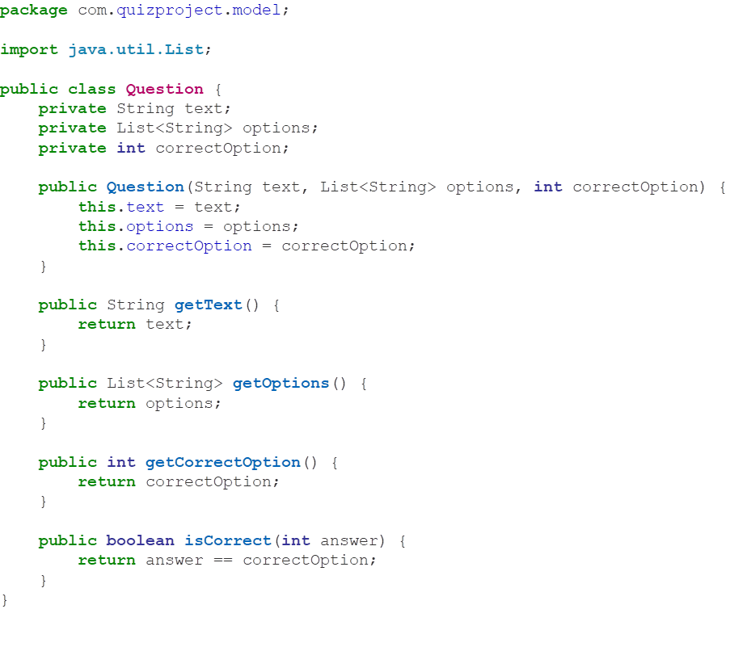

*com.quizproject.model.Quiz.java*



*com.quizproject.data.QuestionBank.java*

­

*com.quizproject.service.QuizManager.java*





*com.quizproject.Main.java*



7. Implementation

Development Environment

* IDE: Eclipse IDE.
* JDK: JDK 8 or higher.

Implementation Process

The implementation process involves creating the necessary packages and classes, defining the methods for managing quizzes, adding questions, and evaluating user responses.

Packages and Classes

1. **com.quizproject**

* **Main.java:** Contains the **main** to start the application.

2. **com.quizproject.model**

* **Question.java:** Defines the structure of a quiz question.
* **Quiz.java:** Manages the quiz-taking process.

3. **com.quizproject.data**

* **QuestionBank.java:** Provides a collection of quiz questions.

4. **com.quizproject.service**

* **QuizManager.java:** Manages the creation and execution of quizzes.

8. Usage and Instruction

Setting Up the Development Environment

1. **Install JDK:**

* Download and install JDK 8 or higher from [Oracle](https://www.oracle.com/java/technologies/javase-downloads.html).

2. **Install Eclipse IDE:**

* Download and install Eclipse IDE from Eclipse Downloads.

3. **Clone the Project:**

* Clone the project repository to your local machine.

Running the Application

1. Open the project in Eclipse.
2. Navigate to **Main.java** in the **com.quizproject** package.
3. Right-click on **Main.java** and select **Run As > Java Application**.

User Guide

1. **Enter User Name:**

* When prompted, enter your name.

2. **Take the Quiz:**

* Answer the questions displayed. For each question, type the number corresponding to your choice and press Enter.

3. **View Score and Feedback:**

* After completing the quiz, your score and feedback will be displayed.

9. Testing and Validation

Testing Strategy

* **Unit Testing:** Test individual methods for correct functionality.
* **Integration Testing:** Ensure that different components interact correctly.
* **User Acceptance Testing (UAT):** Validate the application with end users.

Test Cases

*Test Case 1: Adding Questions*

* **Input:** Add a question to the quiz.
* **Expected Output:** The question should be added to the quiz’s question list.

*Test Case 2: Taking the Quiz*

* **Input:** Add a question to the quiz.
* **Expected Output:** The correct score should be calculated based on the user's answers.

Test Results

All test cases were executed, and the results were as expected. The application correctly adds questions, evaluates answers, and displays scores.

10. Result and Discussion

Summary of Results

The Quiz Project successfully meets its objectives. It allows users to create quizzes, add questions, take quizzes, and receive feedback based on their performance.

Performance Analysis

The application performs well for the intended use case of a command-line quiz application. It handles user inputs and evaluates responses efficiently.

Limitations

* Limited to command-line interface.
* Supports only multiple-choice question.

Future Enhancements

* Implement a graphical user interface (GUI).
* Add support for more question types.
* Integrate with online learning platforms.

11. Conclusion

The Quiz Project is a functional and efficient command-line application for creating and taking quizzes on Java programming. It provides a solid foundation for further development and enhancements, such as adding a GUI and expanding the question bank.